BO meiobenthos turbellarians, nematodes

Meiobenthic fauna consist mainly of grazers adapted to the ingestion of specific microbial

food items such as bacteria and microalgae (Gerlach 1978, Colijn & de Jonge 1984, Moens & Vincx 1997).

Turbellarians: Most other turbellarians are carnivorous, either preying on small invertebrates or [protozoans](http://en.wikipedia.org/wiki/Protozoa), or scavenging on dead animals. A few feed on larger animals, including [oysters](http://en.wikipedia.org/wiki/Oyster) and [barnacles](http://en.wikipedia.org/wiki/Barnacle), while some, such as [*Bdelloura*](http://en.wikipedia.org/w/index.php?title=Bdelloura&action=edit&redlink=1), are [commensal](http://en.wikipedia.org/wiki/Commensal) on the gills of [horseshoe crabs](http://en.wikipedia.org/wiki/Horseshoe_crab).

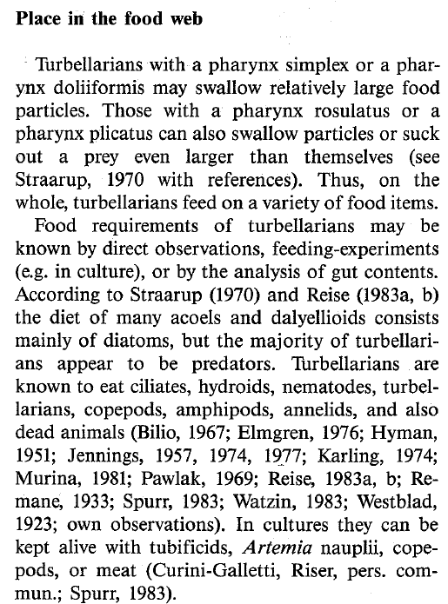

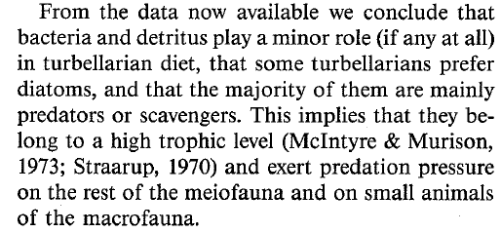

Nematodes:

For example, in the mudflats of Marennes-Oléron Bay, France, where vascular plants such as *Spartina* are virtually absent, benthic diatoms represented the main food source ingested (Montagna et al. 1995) and assimilated by nematodes over a sampling year (Riera et al. 1996). In contrast, in the salt marsh of Aiguillon Bay, France, stable isotope studies of nematodes suggested a higher diversity of food sources, including benthic diatoms and detritus derived from other sources (Riera et al. 1999). This was consistent with the suggestion of Couch (1989) that microphytobenthos does not constitute the sole food source of nematodes, and that detri tus derived from marine phanerogams can be an important food source for meiofauna. When considering that nematodes dominated in the meiofauna of the 3 microhabitats investigated (Fig. 2), and considering the intermediate trophic position of meiofauna, the food web of this area appears to be largely based on the use of stranded macroalgae by feeding nematodes.

|  |  |
| --- | --- |
| **prey item** | **probability of consuming** |
| ZMI microzoo | 0.3 |
| DC carion | 0.3 |
| BFF oyster barnacle hydroid | 0.3 |
| BG horshoe crab amphipod | 0.3 |
| PL diatoms | 0.3 |
| BO nematode | 0.3 |
| ZME copepod | 0.3 |
| DL detritus | 0.3 |
| BO meiofauna | 0.3 |
| MI benthic diatoms (microalgae) | 0.3 |
| DR | 0.3 |
| BAC | 0.3 |

References:

Martens, P.M., Schockaert, E.R. The importance of turbellarians in the marine meiobenthos: a review.

<http://researchdata.museum.vic.gov.au/polychaetes/platyhelminthes.htm>

P. Riera*, C. Hubas 2003 Trophic ecology of nematodes from various microhabitats of the Roscoff Aber Bay (France): importance of stranded macroalgae evidenced through δ13C and δ15N. Marine Ecology Progress Series Vol. 260: 151–159,

Majdi, Nabil and Tackx, Michèle and Traunspurger,